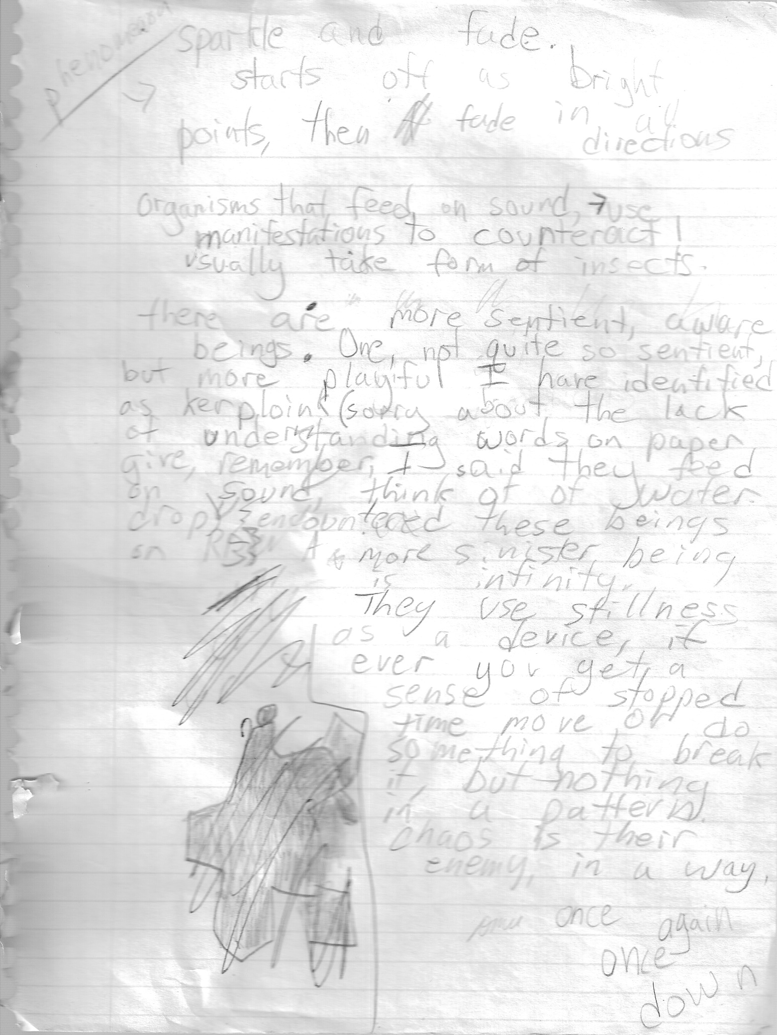
Phenomenon: sparkle and fade. Starts out with bright points, then fades in all directions. Organisms that feed on sound use manifestations to counteract. usually come in the form of insects. There are more sentient, aware beings. One, not quite so sentient but more playful, I have identified as kerploink! (sorry about the lack of understanding words on paper give. Remember, I said they feed on sound. Think of a water drop. Encountered these (figure) on RC. More sinister beings, they use stillness as a device. If you ever get a sense of stopped time move or do something to break it, but nothing in a pattern. Chaos is their enemy, in a way.
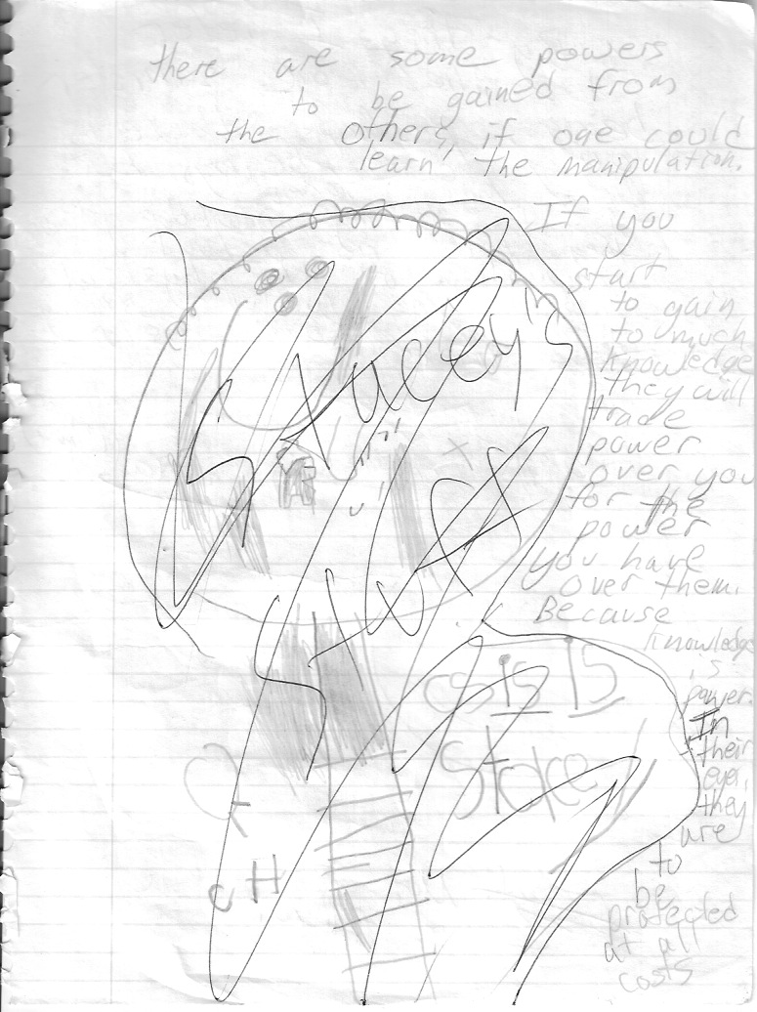
There are some powers to be gained from the Others, if one could learn the manipulation. If you start to gain too much knowledge, they will trade power over you for the power you have over them. Because knowledge is power. In their eyes, they are to be protected at all costs
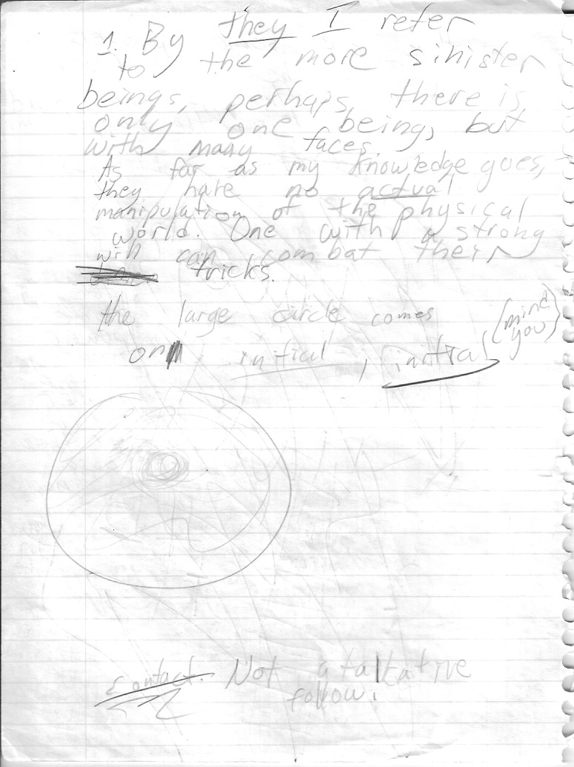
1. By they I refer to the more sinister beings. Perhaps there is only one being, but with many faces. As far as my knowledge goes, they have no actual manipulation of the physical world. One with a strong will can combat their tricks. The large circle comes on initially—initially, mind you. Contact. Not a talkative fellow!
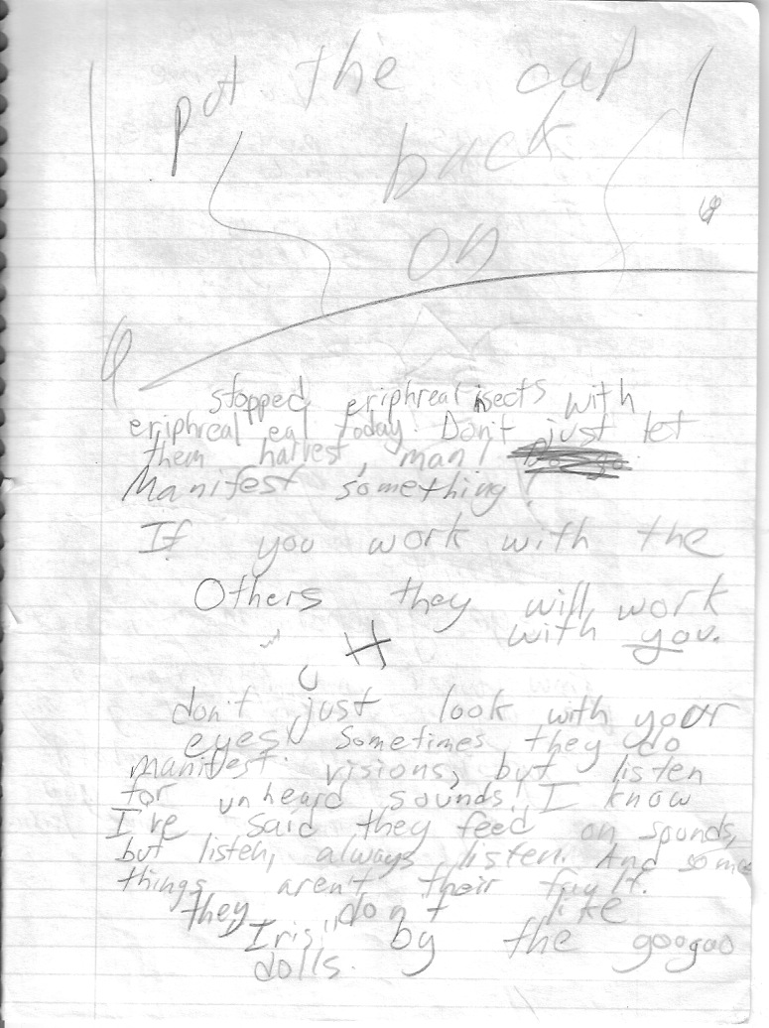
Stopped ethereal insects with ethereal eel, today. Don’t just let them harvest, man! Manifest something! If you work with the Others, they will work with you. Don’t just look with your eyes. Sometimes they do manifest visions, but listen for unheard sounds. I know I’ve said they feed on sounds, but listen, always listen. And some things aren’t their fault. They don’t like “Iris,” by the googoo dolls.
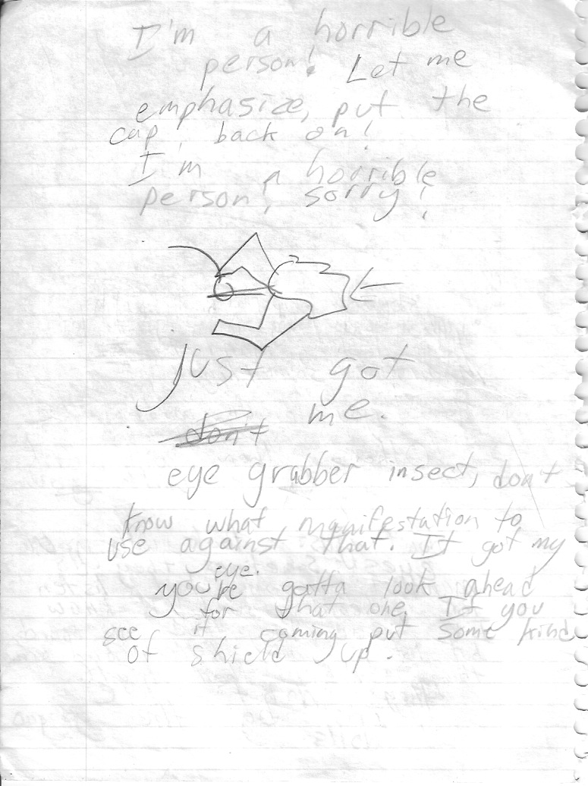
I’m a horrible person! Let me emphasize: put the cap back on! I’m a horrible person! Sorry! [image] Just got me. Eye grabber insect, don’t know what manifestation to use against that. It got my eye. You’ve gotta look ahead for that one. If you see it coming put up some kind of shield.
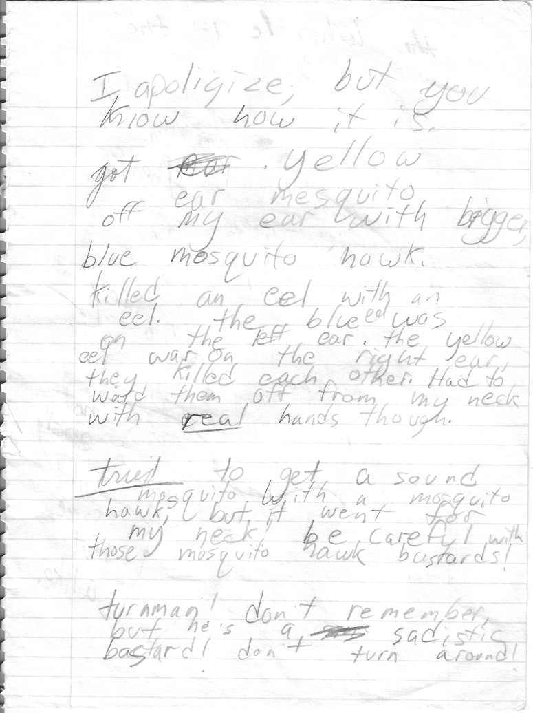
I apologize, but you know how it is. Got yellow ear mosquito off my ear with bigger, blue mosquito hawk. Killed an eel with an eel. The blue eel was on the left ear. The yellow eel was on the right ear—they killed each other. Had to ward them off from my neck with real hands, though. Tried to get a sound mosquito with a mosquito hawk, but it went for my neck! Be careful with those mosquito hawk bastards.
Turnman! don’t remember, but he’s a sadistic bastard. don’t turn around!
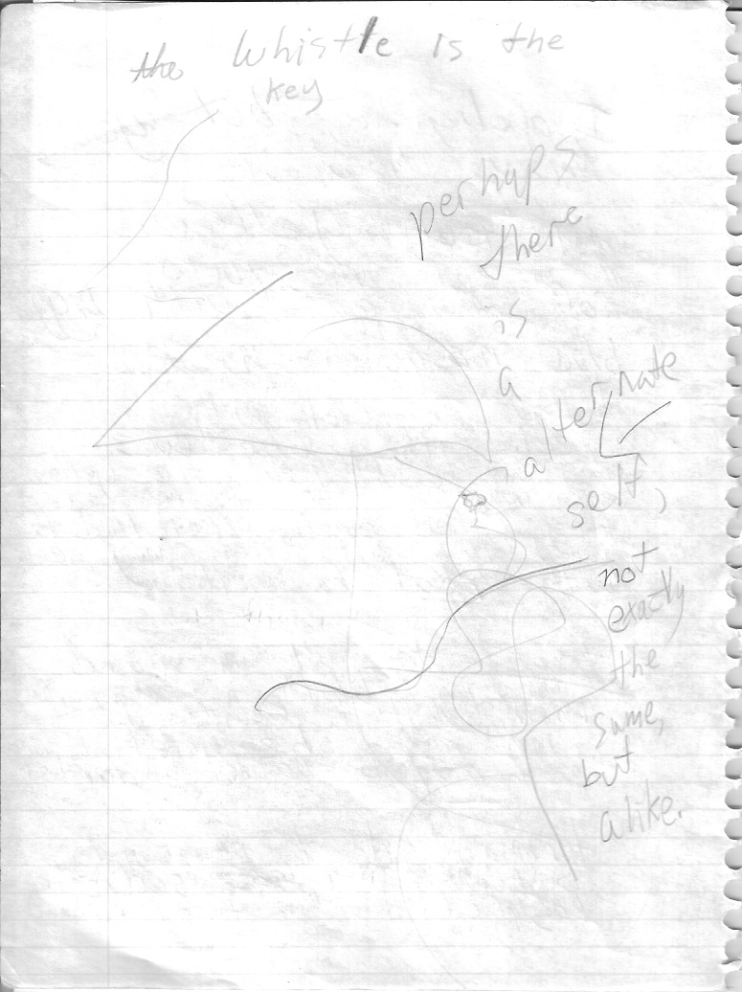
The Whistle is the key. Perhaps there is an alternate self, not exactly the same, but alike.

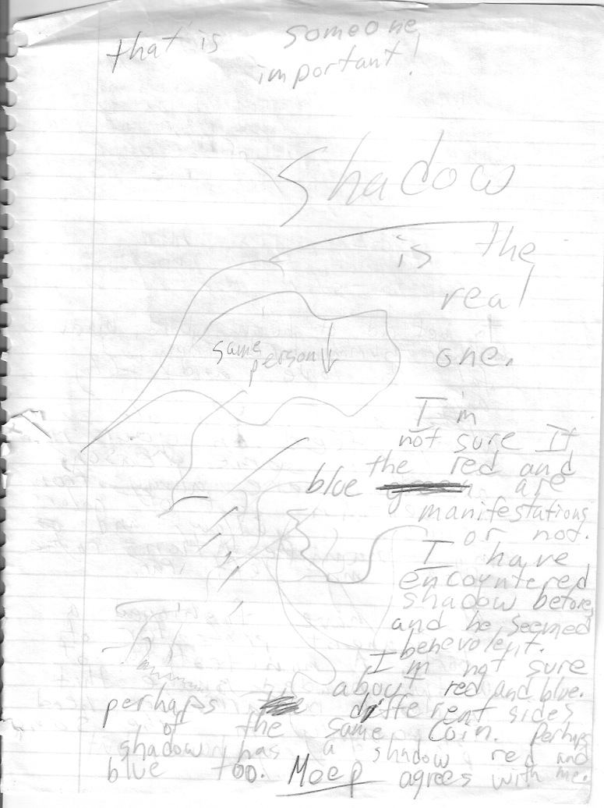
This is someone important! Shadow is the real one. I’m not sure if the red and blue are manifestations or not. I have encountered Shadow before, and he seemed benevolent. I’m not sure about red and blue. Perhaps different sides of the same coin. Perhaps Shadow has a Shadow red and Blue too. Meep agrees with me.
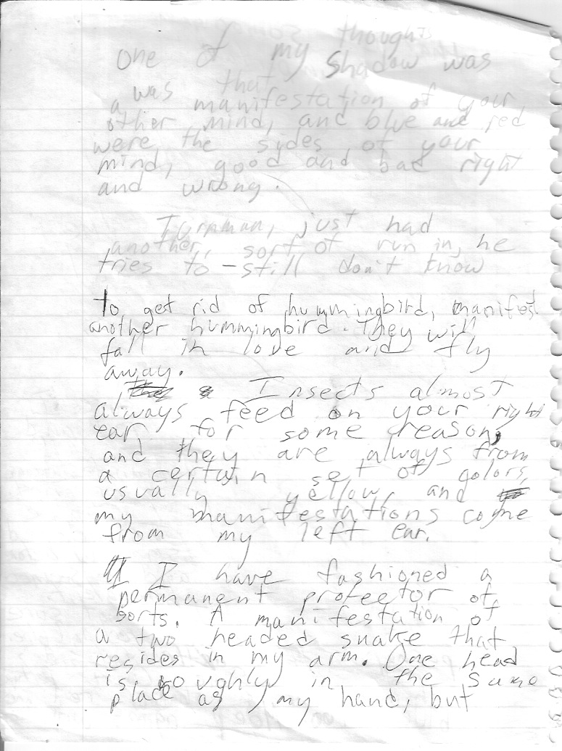
One of my thoughts was the Shadow was a manifestation of your other mind, and blue and red were the sides of your mind, good and bad right and wrong. Turnman—just had another, sortof run in, he tries too—still don’t know. To get rid of hummingbird, manifest another hummingbird. They will fall in love and fly away. Insects almost always feed on your right ear, for some reason, and they are always from a certain set of colors, usually yellow, and my manifestations come from my lest ear. I have fashioned a permanent protector of sorts. A manifestation of a two headed snake that resides in my arm. One head is roughly in the same place as my hand, but
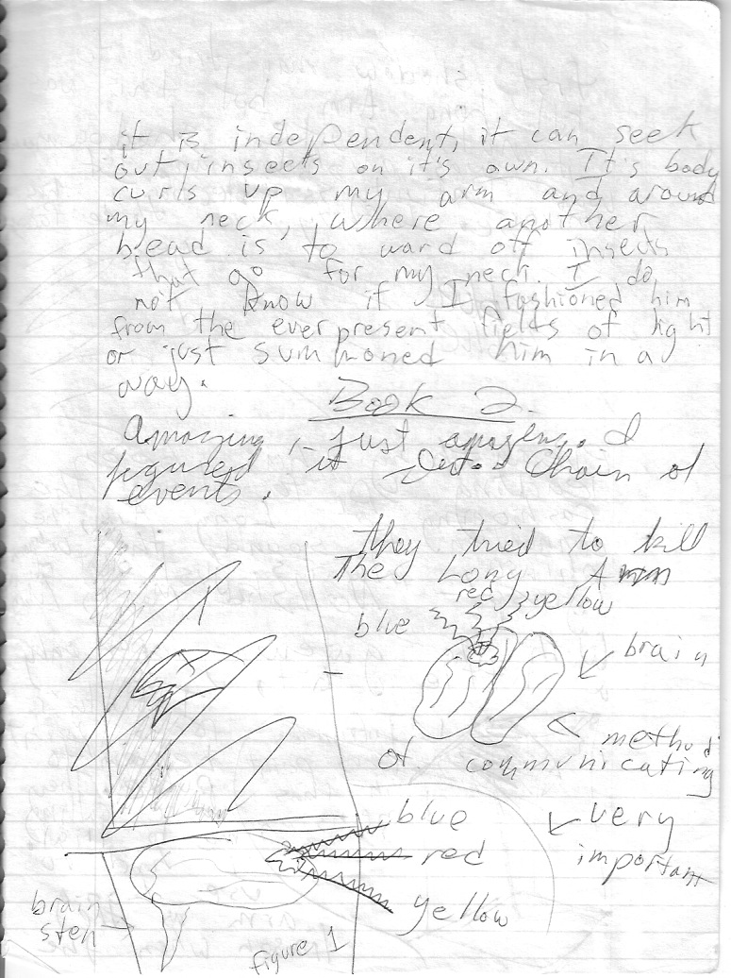
it is independent, it can seek out insects on its own. Its body curls up my arm and around my neck, where another head is to ward of insects that go for my neck. I do not know if I fashioned him from the everpresent fields of light or just summoned him, in a way. Book 2: Amazing, just amazing. I figured it out. Chain of events. they tried to kill the Long Arm--
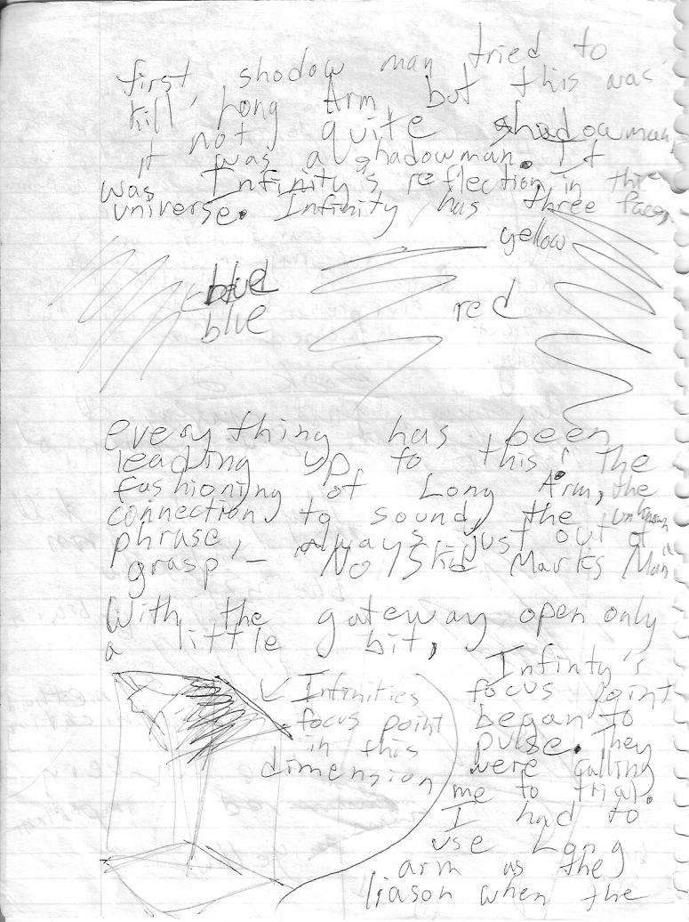
first shadow man tried to kill Long Arm, but this was not quite shadowman, it was a shadowman. It was Infinity’s reflection in the universe. Infinity has three faces—blue, yellow, red. Everything has been leading up to this! The fashioning of Long Arm, the connection to sound, the unknown phrase—No Skid Marks, Man! With the gateway open only a little bit, Infinity’s focus point began to pulse. They were calling me to trial. I had to use Long Arm as the liaison when the
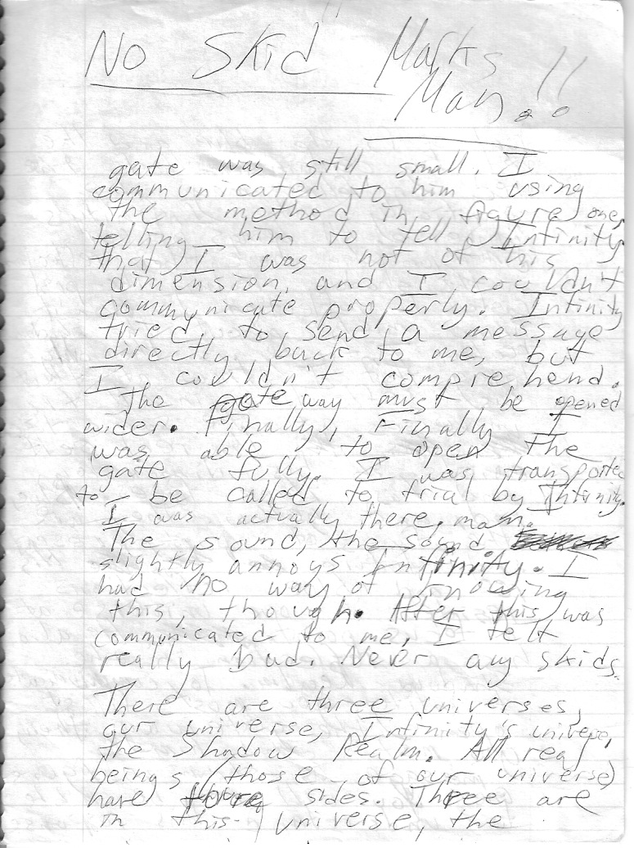
gate was still small. I communicated to him using the method in figure one, telling him to tell Infinity that I was not of his dimension, and I couldn’t communicate properly. Infinity tried to send a message directly back to me, but I couldn’t comprehend. The way must be opened wider. Finally, finally I was able to open the gate fully. I was transported to be called to trial by Infinity. I was actually there. The sound, the sound slightly annoys Infinity. I had no way of knowing this, though. After this was communicated to me, I felt really bad. Never any skids. There are three universes—our universe, Infinity’s universe, and the Shadow Realm. All real beings (those of our universe) have three four sides. Three are in this universe, the
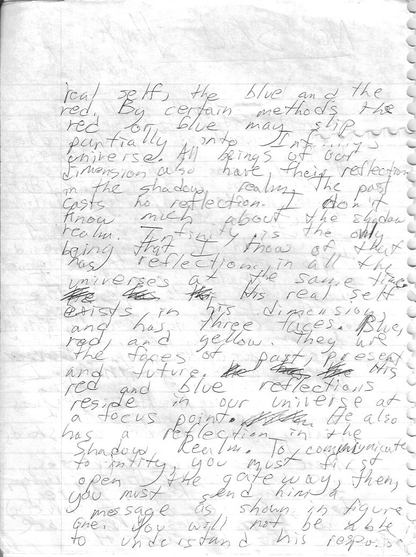
real self, the blue and the red. By certain methods the red or blue may slip partially into Infinity’s universe. All beings of our dimension also have their reflection in the Shadow Realm. The past casts no reflection. I don’t know much about the shadow realm. Infinity is the only being that I know of that has reflections in all the universes at the same time. His real self exists in his dimension, and has three faces. Blue, red, and yellow. They are the faces of the past, present, and future. His red and blue reflections reside in our universe at a focus point. He also has a reflection in the Shadow Realm. To communicate initially, you must first open the gateway, then you must send him a message as shown in figure one. You will not be able to understand his response.
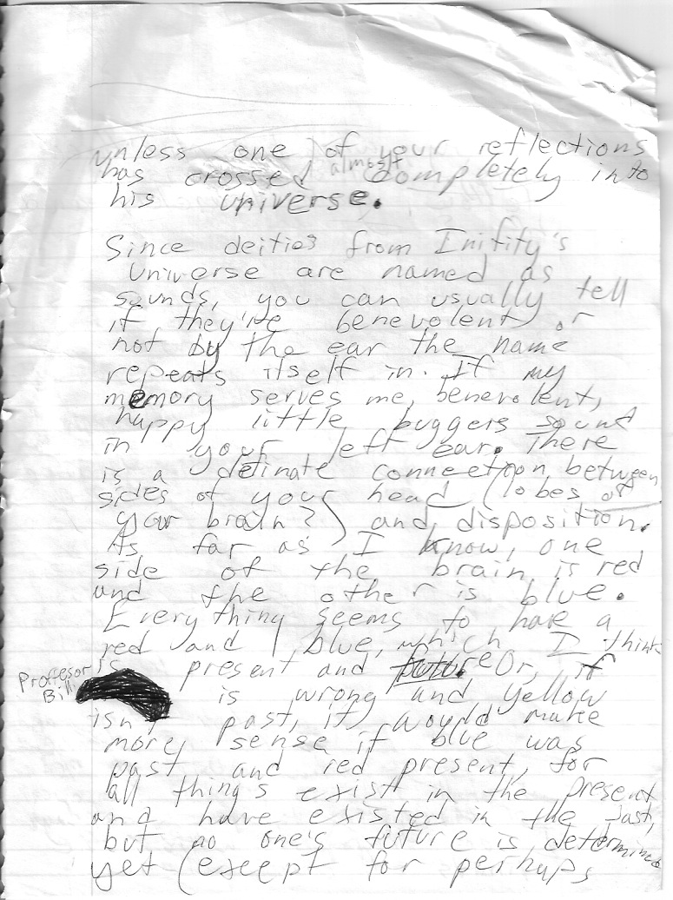
unless one of your reflections has crosses almost completely into his universe. Since deities from Infinity’s universe are named as sounds, you can usually tell if they’re benevolent or not by the ear the name repeats itself in. If memory serves me, benevolent, happy little buggers sound in your left ear. There is a definite connection between sides of your head (lobes of brain) and disposition. As far as I know, one side of the brain is red and the other is blue. Everything seems to have a red and a blue, which I think is present and future. Or, if I’m wrong and yellow isn’t past, it would make more sense if blue was past and red present, for all things exist in the present, and have existed in the past, but no one’s future is determined, yet (except for perhaps

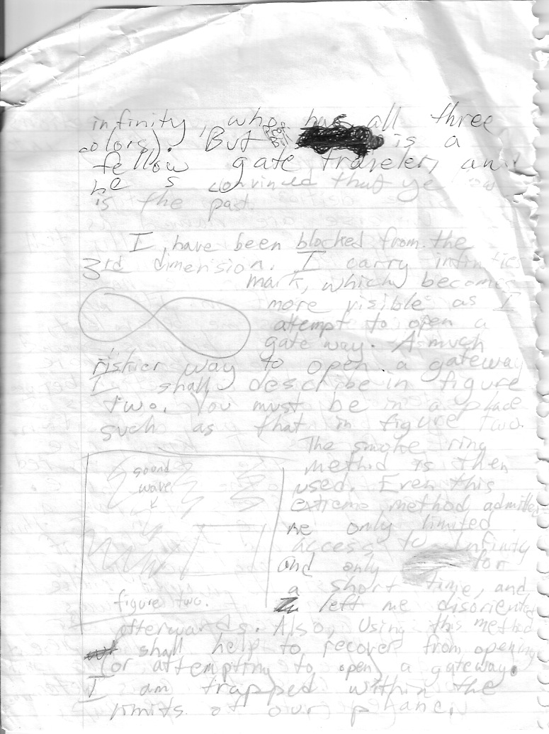
Infinity, who has all three colors. But Professor Bill is a fellow gate traveler, and he is convinced that yellow is the past. I have been blocked from the third dimension. I carry Infinity’s mark, which becomes more visible as I attempt to open a gateway. A much riskier way to open a gateway, I shall describe in figure two. You must be in a place such as that in figure two. The smoke ring method is then used. Even this extreme method admitted only limited access to Infinity, and only for a short time, and left me disoriented afterwards. Also, using this method shall help to recover from opening (or attempting to open) a gateway. I am trapped within the limits of our power.

